**😊 Lab 3 (Python) - Develop Solutions Using Amazon DynamoDB**

1. Download the zip file for lab 3, unzip it then open it in VS Code.
2. Now go to config.ini file and here you must change the path for source notes.

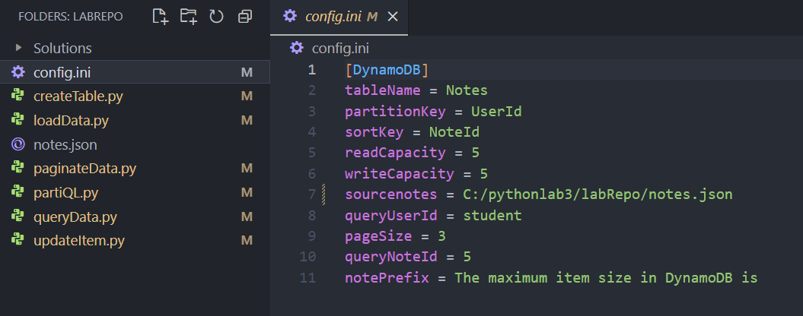

1. Then go to create table file and change the path for read config. Then use the below command to execute the create table. This will all you to create a dynamo db table in your AWS Console.

**python createTable.py**

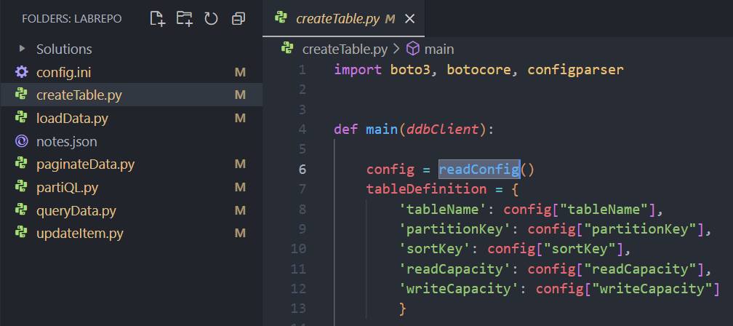

1. Then we need to go to load the data file and similarly we are going to change path for read config as we did earlier and run this command to load the data into our table.

**python loadData.py**

1. Now move to the query data file and do the same things as before then run the below command.

**python queryData.py**

1. Similarly, go to the paginate data file, change the path, and execute it.

**python paginateData.py**

1. In the end you are going to update item file, do the same things then run the command to execute it.

**python updateItem.py**

1. Also, after every command go to your Dynamo DB table and check for the changes that are being made.